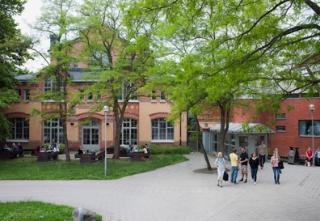

Welcome to Stockholm University!
We are happy that you have chosen to start working with us and look forward to seeing you here soon.
Stockholm University is characterised by openness, innovation and cross-boundary operations in the capital of Sweden. Stockholm University contributes to knowledge development in a global perspective and in collaboration with others. This is done at the international forefront through education and research in Human Science and Science, as well as cross-boundary inter- and multidisciplinary research.
We have compiled the most important terms of employment that are relevant to your position in You and Your Workplace. More information can be found on the University’s staff website: www.su.se/english/staff/personnel.
In order for your salary to be paid correctly, our bank needs information about your bank account. Once you have been registered in our HR system, you can provide your bank account details to Danske Bank.
Please, feel free to contact us if you have any questions.
Best regards,
The receiving department

